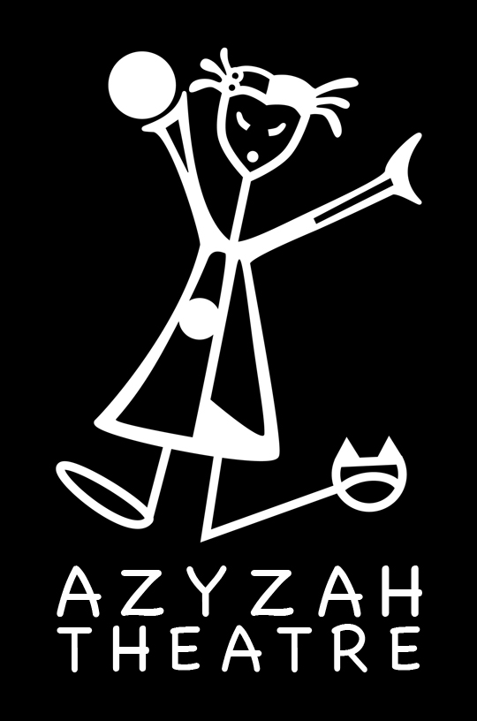

Azyzah Theatre
English Educational Theatre

Whoop Concert * Student/Teacher Material
Exercises for students (before the performance)

This Student / Teacher Pack contains lesson plans related to the interactive Magic Concert show.

All lessons are a supplement to the show for preschool & basic schools year 1-3 and may be adapted to each level as teachers see fit.

Azyzah Theatre may be contacted for guidance related to all lessons.

Contact:
Vanessa Gendron ( Director, Creator)
tel. (+420) 608 454 655
email. Vanessa@azyzah.com
www.azyzah.com

FOCUS
Students will learn a multiple of new English songs with the help of the Magic Concert Music link available on the website.

Supporting materials are :

-Songs with lyrics
-Worksheets
-Interactive game where we explore each song
-Communicative English

TOPIC 1 Comprehension

Tell the children the basic story outline of the Magic Concert.

In this SHOW you will meet Kiki and her puppet friends.

Kiki finds her friends in her golden suitcase…they join the concert and sing several songs with the students.

-A little green frog
-A cat, pig, cow and a dog
-A chicken
-Dino song
-A spider
-Two panda bears
-Crocodile
-Whale

TOPIC 2 – Song Lyrics

Learning a language is particularly encouraging when you can sing to it. Students love to sing. Singing with movement helps to discover the meaning of each word and the message of the entire song. Learn new songs while listening to the music soundtrack available on the website link.

1) Dino Song ( Like Do you know the Muffin Man ( tune) )

Do you know the Dino Roar, Dino Roar, Dino Roar. Do you know the Dino Roar, Yes he has a mango nose, strawberry eyes, banana lips…………

2) Rock you

We will, we will rock you.
*continue with rhythm and different sounds

3) Row, row, row your Boat

Row, row, row your boat, gently down the stream,
Merrily, merrily, merrily, life is but a dream.

4)Head, Shoulders, Knees, and Toes

Head, shoulders, knees and toes,
Knees and toes.
Head, shoulders, knees and toes, Head, shoulders, knees and toes,
Knees and toes.
Head, shoulders, knees and toes,
Knees and toes.
And eyes and ears and mouth and nose
Head, shoulders, knees and toes,
Knees and toes.
Knees and toes.
And eyes and ears and mouth and nose
Head, shoulders, knees and toes,
Knees and toes.

5) Old Mac Donald had a Farm

Old MacDonald had a farm Ee-yi-ee-i-oh And on this farm there was a dog Ee-yi-ee-i-oh With a woof woof here And a woof woof there Here a woof There a woof Everywhere a woof woof Old MacDonald had a farm Ee-yi-ee-i-oh…
2nd verse: cat/meow 3rd verse: horse/neigh 4th verse: duck/quack 5th verse: cow /moo 6th verse: pig/oink
6) The little Green Frog (best song of 2007 Summer Camp**)

Hum hum said the little green frog one day,
Hum hum said the little green frog,
Hum hum said the little green frog one day,
All frogs go hum hum ha…
But we know frogs go – sha la la, sha la la, sha la la, sha la la
But we know frogs go – sha la la, sha la la, sha la la, sha la la
And frogs don’t go hum hum haaaa

7) Chick Chick

Chick, chick chick, chicken lay a little egg for me,
Chick, chick, chick, chicken I want one for my tea,
I haven’t had an egg since lunchtime and now it’s half past three,
Sooooooo chick, chick, chick, chicken lay a little egg for me.

8) Panda Bears

We’re the Panda Bears, Bears, Bears,
Black eyes and black ears, ears, ears
We like to chew, chew, chew,
On the leaves of Bamboo, boo, boo,
We come from china,
That’s where we learn kung foo, foo, foo
We’re really good at it too, too, too
Azyzah Productions
420 602 772 498
www.azyzah.com

Whoop Concert WORKSHEET 1

Directions: Write the Onomatopoeia ( name) next to the correct animal.

Dino Spider Chick

frog panda whale spider

crocodile

ROAR………………………………

Hiss………………………………..

Purr………………………………..

Ribbit………………………………..

Cock-a-doodle-doo………………..

Squeak………………………………..

Click………………………………..

Whoop Concert WORKSHEET 1A

Directions: Match the animals to the country where we met them.

Fill in the spaces by using the words from the word bank.

Dino Africa

Spider world

chick South America

frog North America

panda Antartica

whale Australia

spider Africa

crocodile Europe

Whoop Concert WORKSHEET 2

If your happy

Directions: Fill in the spaces by using the words from the word bank.

Know clap feet

shout

If your____________and you know it!

__________ know your hands.

If your happy and you __________ it!

Stomp your __________.

If your happy and you know it!

__________hurray!

Whoop Concert WORKSHEET 3
Match the sounds to the animal.

cow (oink – snort)

dog (quack)

cat (moo)

sheep (cluck)

donkey (clop-neigh)

chicken (bleet-baa)

horse (squeak-drum)

rabbit (bark-woof)

pig (meow)

duck (hee-haw)

TOPIC 3 - Interactive Communication
Learning English animal sounds

1-Prepare a set of flashcards
Print a set of flashcards with the name of the farm animal and the sound they make.

Main list : cow (moo), dog (bark-woof), cat (meow), sheep (bleet-baa), donkey (hee-haw), chicken (cluck), horse (clop-neigh), rabbit (squeak-drum)
pig (oink – snort), duck (quack)

2-Teach the songs to the students.

Old MacDonald had a farm Ee-yi-ee-i-oh And on this farm there was a dog Ee-yi-ee-i-oh With a woof woof here And a woof woof there Here a woof There a woof Everywhere a woof woof Old MacDonald had a farm Ee-yi-ee-i-oh….
2nd verse: cat/meow
3rd verse: horse/neigh 4th verse: duck/quack 5th verse: cow /moo 6th verse: pig/oink

3- Interactive game

Once the children know the song, give them each a card – half the class should have the animal pictures and the other the names with sounds.

They now circulate the room and find their matching cards while making the animal noises.

